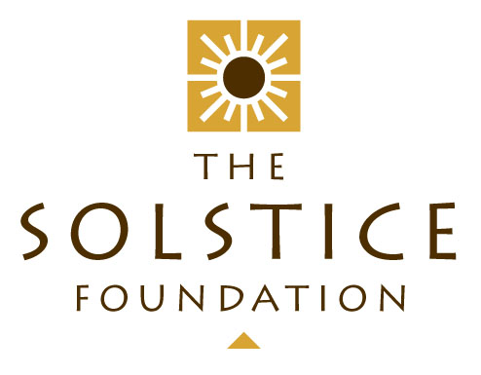

ANNUAL REPORT

YEAR ENDING – 29 February 2016

TABLE OF CONTENTS

INTRODUCTION AND OVERVIEW 1
EXECUTIVE COMMITTEE 1
BENEFICIARIES 2
Biblionef 2
Busy Bee Rugby Football Club 2
SERI 3
Sporting Chance Foundation 3
Trinity Childrens’ Centre 4
ORION Organisation 4
FUNDRAISING AND OTHER EVENTS 5
“Art by the Glass” Exhibition 5
“Friends of Solstice”: 5
Web presence and Social Media 6
My School 6
FINANCIAL REPORT: 7
CONTACT DETAILS: 7

INTRODUCTION AND OVERVIEW

The Financial Year ending 29 February 2016 marks the 14th anniversary of The Solstice Foundation’s existence. Over all these years, we can proudly reflect that we have never experienced an “unhappy donor”. Our financial accountability has been unblemished and, without exception, our projects have fulfilled their stated objectives. Our monitoring and diligence processes have ensured that our undertakings have not “gone up in smoke” and we have shone brightness into 1000’s of lives. We have stuck within what Warren Buffett refers to as our “circle of competence” and remained true to our core strategies. The loyal team of stalwarts comprising the Executive Committee should take credit for these successes – none of which would have been possible without their dedication and passion. It is indeed a pleasure and a privilege to serve on this body.

Thanks to an interesting analysis from our creative accountant, Graham Reynolds, we are proud to announce that, over the 14 completed financial years of our existence, we have raised just over R6 million and distributed to our various beneficiaries an amount of R5.6 million – with the balance of some R400K held in reserve and earmarked for projects in the current year.

On 30 July 2015, we hosted our second “Art by the Glass” art and wine exhibition – this time in “Rococoa” – a unique venue in The Palms Lifestyle Centre in Woodstock. The committee once again pulled together in fine style to produce another successful event – see the more detailed report below.

All in all, and in review, it seems incredible what we have been able to achieve over this time through a committee who just keep on delivering year after year of devoted service – all done with a smile and good heart in the midst of their very busy other lives. The results are a great tribute to each of them.

EXECUTIVE COMMITTEE

The Executive Committee has remained unchanged this year. It comprises: David Burton (Chair), Jo Bell, Kathy Leslie, Graham Reynolds (Treasurer), James Beaumont, Jane Butters and Nicky Burton (Secretary).

The committee has met 9 times during the year under review. Minutes of these meetings are available on request.

BENEFICIARIES

Biblionef

This year again we supported Biblionef with the amount of R25 000. Biblionef’s Vision is to “create lifelong readers who are good citizens, who can read and think for themselves, resulting in a society where everyone is literate; has access to education and finds reading both a great pleasure and a necessity”. The organisation focusses on providing storybooks to children in their mother tongue and in English, countrywide. Their interventions can be in the form of a full school library with equipment and a trained librarian, a smaller-scale ‘trunk’ of books for the classroom or top-up sets of books to replace worn out items or provide a sample of things to come. Most of the funds donated by The Solstice Foundation are used for the transport of books and other necessary overheads.

In February, Kathy Leslie attended a Biblionef function celebrating their contribution to the promotion of mother-tongue books in South Africa as part of International Mother Tongue Day.

Busy Bee Rugby Football Club

This community rugby club based in Langa has been in existence since 1923. Since 2005 it has been affiliated to Western Province Rugby Union and fields teams in various age-group leagues from U8 to U19 (male and female) around Cape Town.

The Senior Team won the City League.

There is still a young team in the Academy and numbers are growing at the club.

One of the Busy Bee players carried the South African flag at the Sevens World Cup, leading the Springboks onto the field before the Samoan game.

The Busy Bee RFC have one under 15 Western Province boy in the 2015 Elite Squad for Western Province.

There remains a partnership with Bishops School for the under 11/12 boys to attend after School programs, three days a week for joint Mathematics, English and Rugby skills sessions.

The Women’s team is doing well and the Busy Bee RFC have five Western Province ladies in the 2015 squad, one of them is the Captain. There are two club members in the under 18 Province ladies team that won the SARU Provincial tournament in Durban in the June holidays as well as three under 16 Provincial players this year from the club.

The club is very proud of their coach, Mr M.A Kewana, who was appointed as Liaison Officer for the Samoan Team in the 2015 World Rugby Sevens Tournament in Cape Town.

The Solstice Foundation supplied 100 T shirts for the teams with the Busy Bee logo on the front so that the teams could attend matches in their team colours.

The Busy Bee Rugby Football Club has maintained contact with the Solstice Foundation following our sponsoring of their transport needs, keeping us up to date on achievements and activities. We have decided to continue our sponsorship of their transport and wish them another great year of rugby.

SERI

SERI is an NPO fundraising partner to the Centre of Science and Technology [COSAT], a specialist school for grades 8 to 12 that operates in Khayelitsha for students with leadership ability and an interest in Maths, IT and Science. COSAT has an excellent academic record achieving a consistent 60% - 80% rate of matric exemptions with Mathematics and Science, and a commendable number of A & B aggregates (7 & 9 respectively in 2015) and subject distinctions. Their top student, Ms Namhla Juqu achieved 100% in Physical Science, only just pipping her Maths mark of 99% - 7 subject distinctions in all. She was the top Physical Science student in the Western Cape. Next in line was Ms Asanda Magoda who also achieved 7 subject distinctions, performing best in Life Sciences (96%) followed by isiXhosa (90%).

COSAT is the biggest township feeder school to local universities. On average 90% of COSAT matriculants enter courses at University of Cape Town, Stellenbosch University, University of Western Cape and the Cape University of Technology.

SERI fundraises for and manages most of the enrichment activities at the school. It also ensures pastoral support, as many of the learners are from very impoverished homes, often with negligible family support.

The Solstice Foundation has supported SERI for several years now and in the year ended 29 February 2016, the Foundation continued to support SERI’s ‘GET’ Bursary programme with a contribution of R100 000.

Sporting Chance Foundation

We have continued our support of this organization in the current year and their letter of thanks inserted here is the best indicator of what has been achieved by them. They received R20 000.00 of our funds.

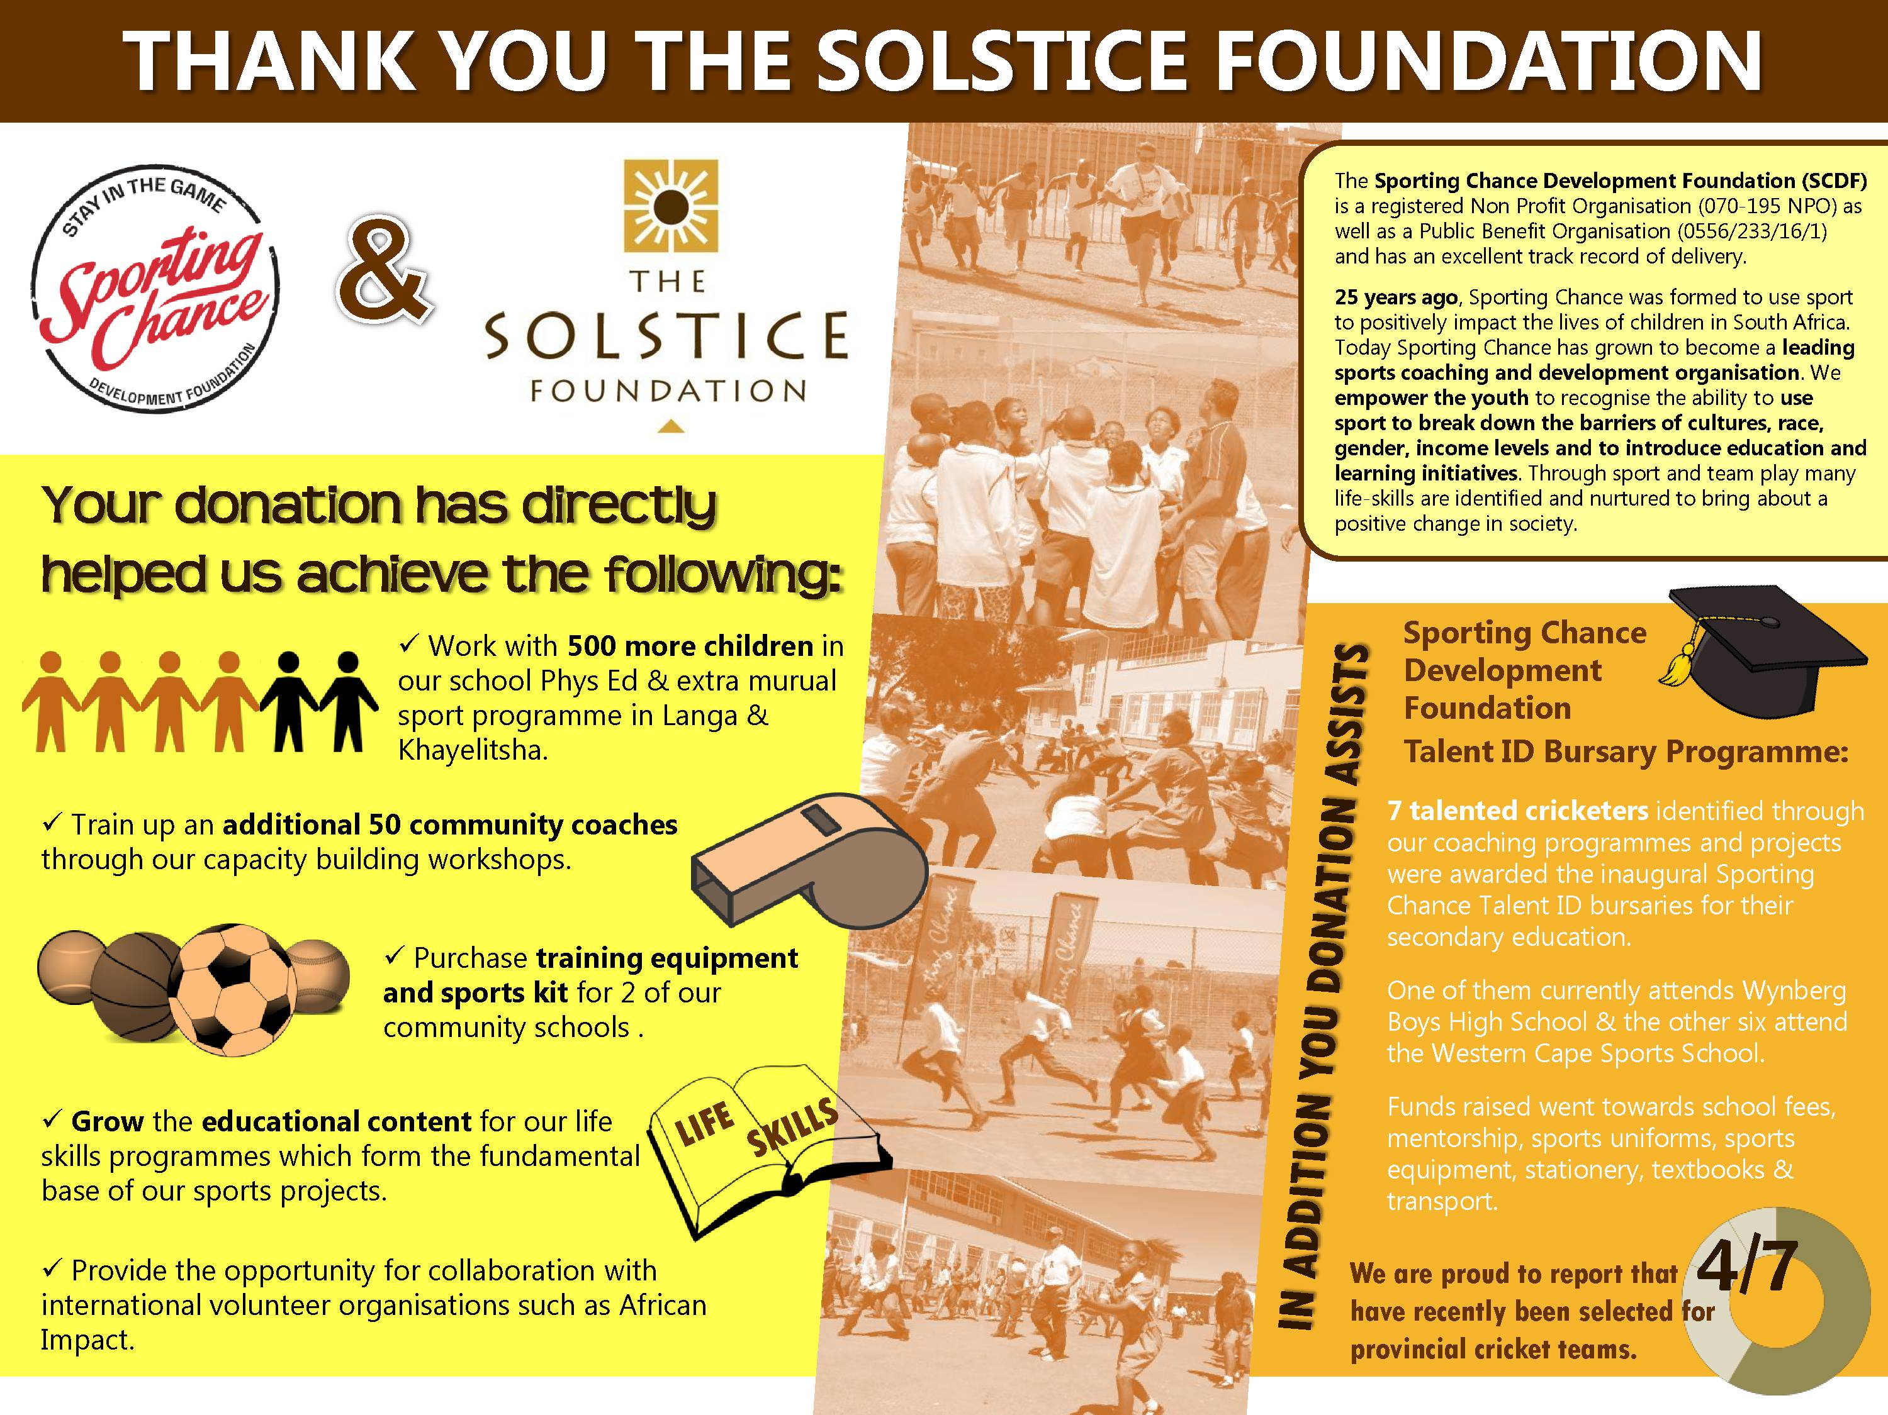

Trinity Childrens’ Centre

We have continued our support for this organization in the year under review. What started as an Early Learning Centre in Mitchell’s Plain now has aspirations to grow into a fully-fledged pre-primary and primary school. Their plan is to expand as their first intake grows through the facility and they’re now into their 5th year with a total of 60 kids and 10 full time staff members. 2016 has seen them opening up a Grade 2 class and they plan to establish a Grade 3 in 2017 for the current 2nd Graders to graduate into.

Over the year in review we have disbursed to them the sum of R144 000.00.

ORION Organisation

The past year has been a challenging one for us at Wilge Special Day Care Centre for Disabled Children in Atlantis. Our bursary student, Laura de Wet, who qualified at the end of 2013 and spent 2014 in KZN working out her community service year, returned to Atlantis to start work as a physiotherapist at Wilge (a subsidiary of the Orion Organisation). Soon after beginning her physio work Laura was asked to take over the role of Centre Manager at Wilge. With our encouragement she spent most of the year working two jobs, often being asked to step ‘into the deep end’ with management tasks, and to set up systems for the improved functioning of Wilge. Solstice paid for Laura’s physiotherapy half-day salary while Orion paid for her management portion.

Although Laura was learning a lot regarding ‘management’ she yearned to spend more time growing as a physiotherapist and working with the children in a practical way. By the end of 2015 we agreed with the Orion CEO that Laura would revert to physiotherapy work only and that Wilge would advertise for a new manager.

Solstice also provided funding for Laura to participate in a course for physiotherapy for patients in wheelchairs, contributing to her CPD points.

We are very proud of Laura’s achievements during the year and her all round tenacity.

FUNDRAISING AND OTHER EVENTS

Since our last Annual Solstice Ball in 2012, we have not hosted any one major fundraising event. Our energies have been focused on establishing links with a wider “Corporate” support base and on improving our communications. We are well geared and suited to attract corporate CSI funds especially from the small to medium sized corporates. Each time we have applied ourselves to this effort, we have been able to raise the funds that have been required so we are setting our sights on becoming more proactive in this exercise.

“Art by the Glass” Exhibition

Our second exhibition was also very well received and supported with almost every exhibiting artist making at least one sale. It is difficult to find the right venue for this event and each year this presents us with the biggest logistical difficulty. Another irritation was the discovery that certain of the exhibitors were acting as agents for other artists and inflating the asking prices to cover their commissions. In future we will be implementing controls to eliminate this mercenary practice. We had some good support from 3 wineries who also were able to make sufficient sales to justify their efforts. So on the whole, there was a great atmosphere and the committee pulled together to ensure that all sales were accurately recorded and the funds collectable. It is always a big effort on the night but it remains entirely manageable with the excellent teamwork delivered. Despite the fairly expensive catering we managed to show a profit of about R33K – more than double from the prior year. The idea is to build this into an annual event which publicizes up and coming artistic talent to a receptive and appreciative audience.

“Friends of Solstice”:

The “Friends of Solstice” are those who make a financial donation to the Foundation, either on a monthly basis or as a once off gift. Donations can be tailored if the donor so wishes, and ‘paid forward’ to the specified beneficiary. During the 2016 financial year a generous total of R145 200 was donated to the Solstice Foundation by the “Friends”. All of these donors have received Section 18A tax certificates.

Web presence and Social Media

Jane Butters manages this portfolio very ably and has generated some great PR in this space. This also represents an incredible archive of our history with details of projects etc. going back to 2002. We aim to build on this in the coming year.

My School

Another initiative of Jane’s, this was a real slog to get up and running. Through sheer persistence, Jane has managed to get the Solstice Foundation listed as a beneficiary of the “My School” program and this now will hopefully become an increasing and steady flow of revenue into our coffers.

FINANCIAL REPORT:

Graham Reynolds continues to successfully manage the finances as the Foundation’s Treasurer. In the year under review, we spent R 524,590 on our various projects and generated an income of R 384K odd. The financials are presented below.
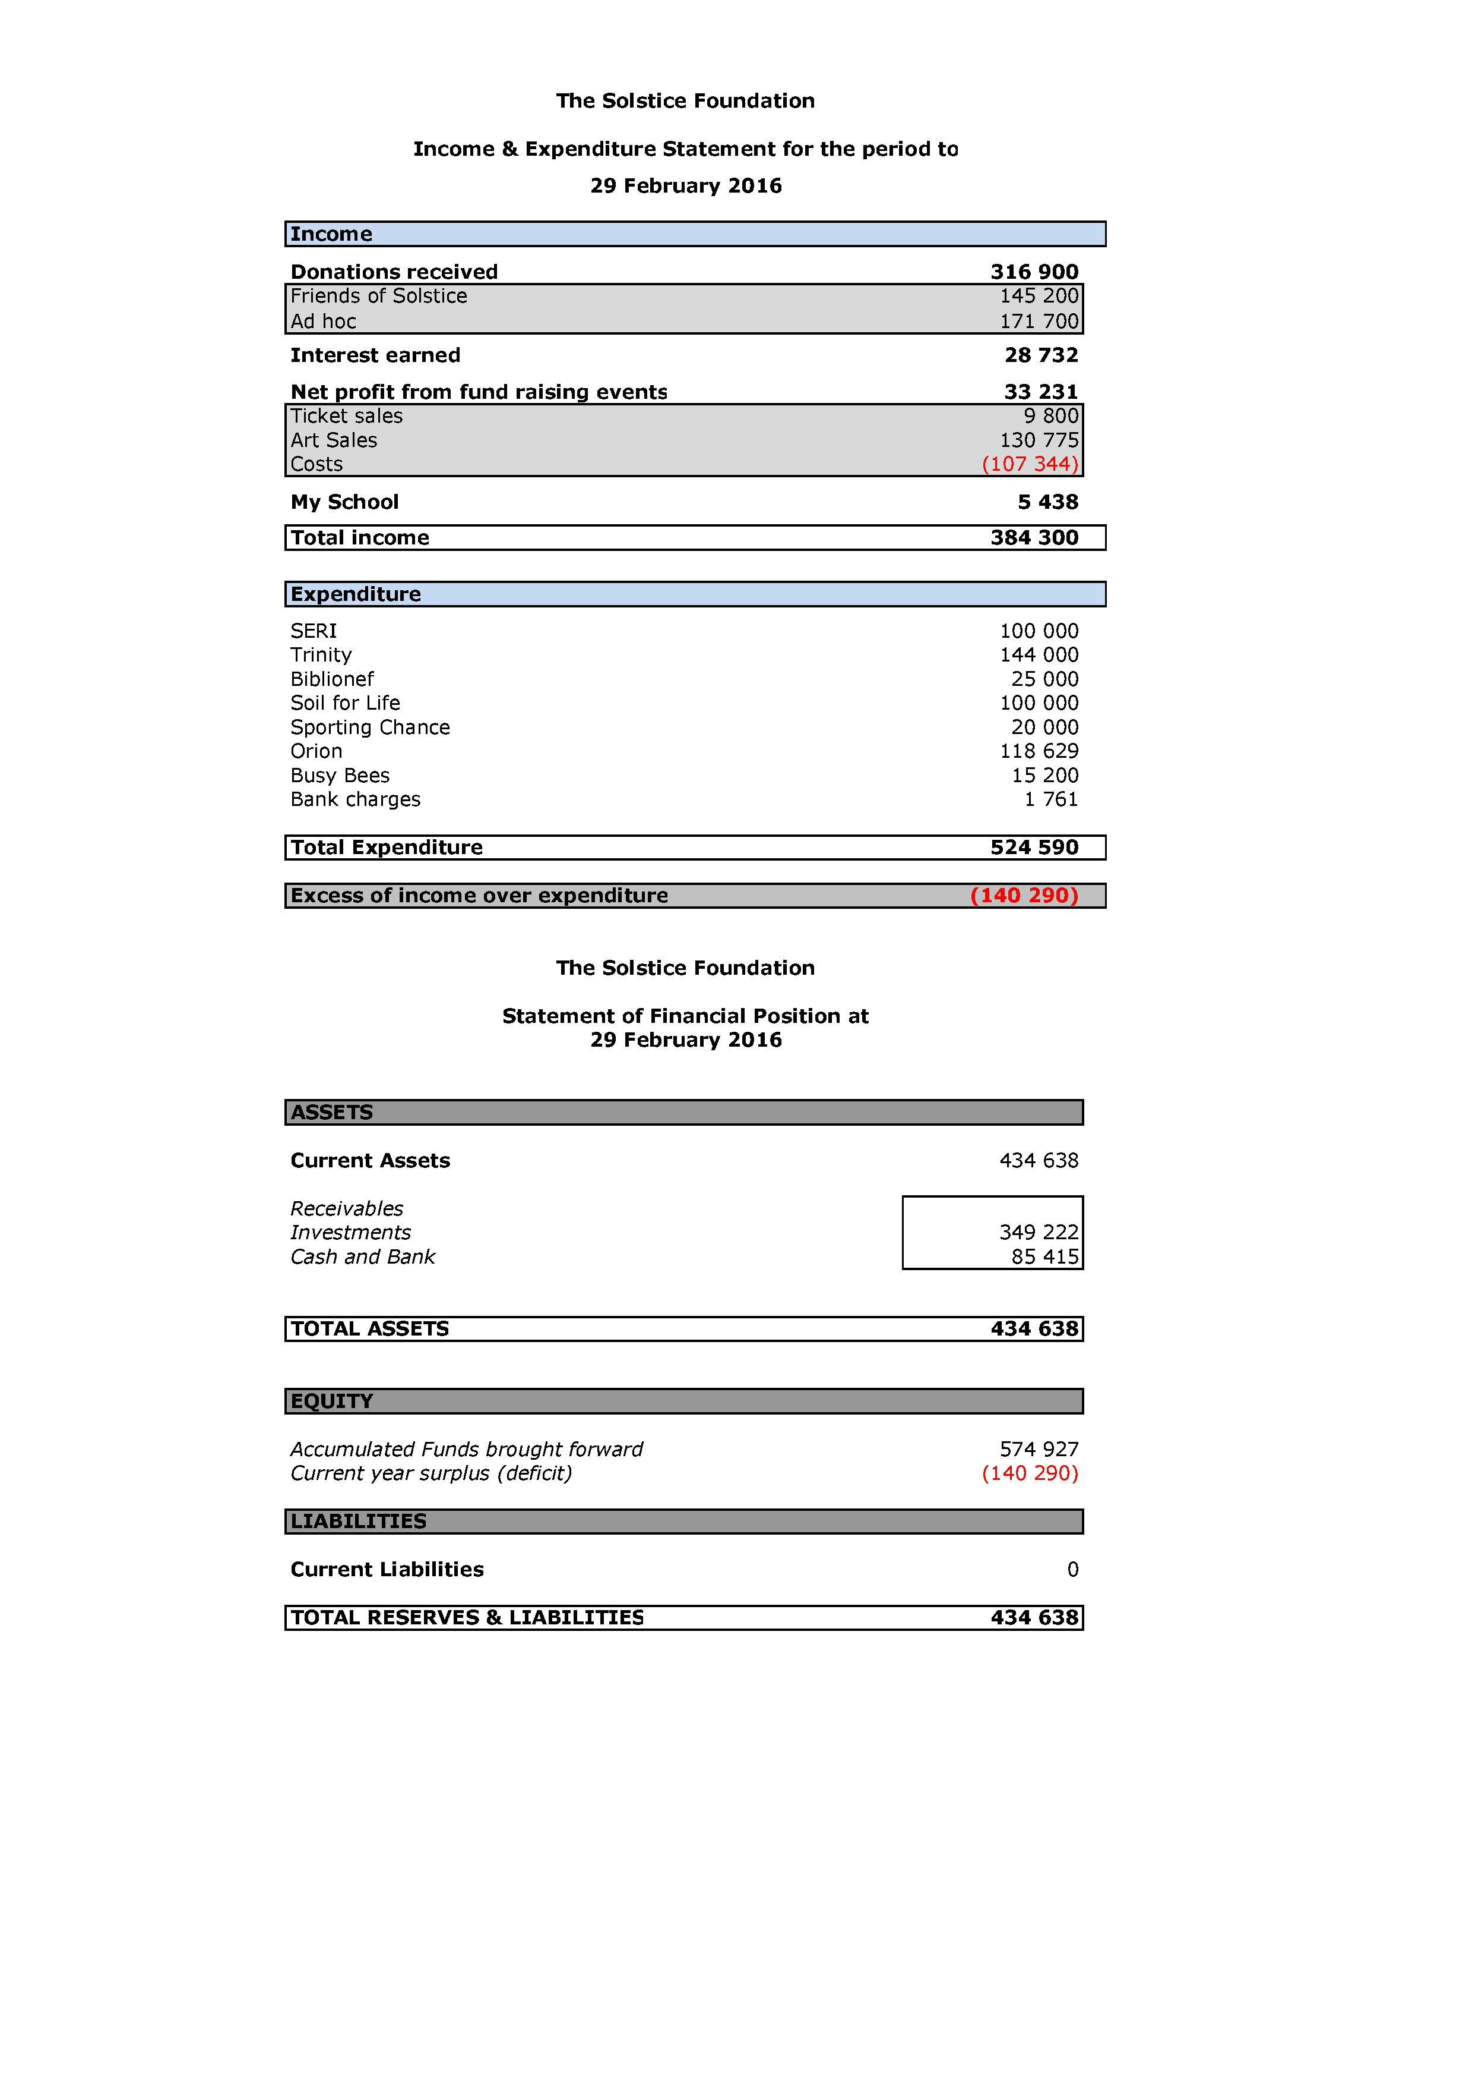

CONTACT DETAILS:
For any further information please contact David Burton at:
P O Box 50333, Waterfront, 8002
Email: dblaw@iafrica.com

