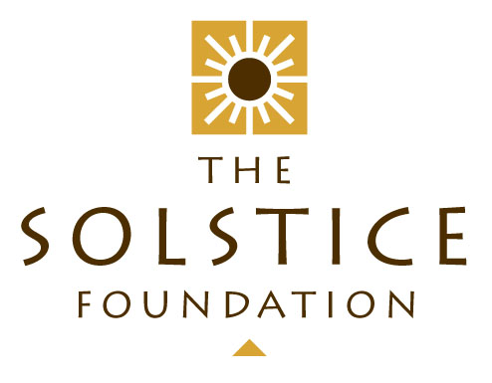

ANNUAL REPORT

YEAR ENDING – 28 February 2018

INTRODUCTION AND OVERVIEW

The Financial Year ending 28 February 2018 marks the 16th anniversary of The Solstice Foundation’s existence. Over all these years, we have maintained an excellent track record with our donors and a high standard of financial accountability. Our monitoring and diligence processes have ensured that our undertakings are fulfilled and we have shone brightness into 1000’s of lives. The loyal team of enthusiasts who make up the Executive Committee should take credit for these successes – It is indeed a pleasure and a privilege to serve on this body.

Our finances are excellently managed by our treasurer, Graham Reynolds, whose report is attached hereto for consideration and adoption by this meeting.

EXECUTIVE COMMITTEE

There have been two members step down from the Executive Committee during the course of the past year: James Beaumont and Jo Bell. We are greatly indebted to both of them for their sterling contributions and would love to think that they will remain loyal supporters of the organization. In their places we are thrilled to have found Ken McKenzie and Craig Byren stepping up to the plate. Their formal appointment is to be approved at this meeting but, already, they have both made inspiring contributions and we are really looking forward to more of this in the years to come. The rest of the members have indicated their willingness to stand for re-election by this meeting and so, if so approved, the Executive Committee for the coming year will comprise: David Burton (Chair), Craig Byren, Kathy Leslie, Ken McKenzie, Graham Reynolds (Treasurer), Jane Butters and Nicky Burton (Secretary).

The committee has met 8 times during the year under review. Minutes of these meetings are available on request.

BENEFICIARIES

We have taken to reporting quite regularly and on an ad hoc basis (whenever there is interesting news) on our various beneficiaries – making good use of our Facebook presence. This record of our activities and those of our beneficiaries is a constant resource and makes it less relevant for each beneficiary to be reported on in detail here.

During the past year, we have continued to be engaged with and support the following beneficiaries:

Biblionef

Baphumelele

Busy Bee Rugby Football Club

Sporting Chance Foundation

Friends of West Coast Ecology and Biodiversity Association (“FOWCEB”)

Trinity Childrens’ Centre

Emmanuelle Day Care Centre

The Principals’ Club

Centre of Science & Technology (“COSAT”)

FUNDRAISING AND OTHER EVENTS

Since our last Annual Solstice Ball in 2012, we have not hosted any one major fundraising event. Instead we are engaging with our individual support base on a more intimate level and are tapping into our wider “Corporate” support base for project funding as and where required. We have held 3 “Solstice Talks” in the past year and these have all proved to be extremely successful. There was Michael Charton’s “My Father’s Coat”, followed by Toni Stuart’s “Crossing the M5” and finally, another crossing – this time of the Pacific Ocean as told through the eyes of Lizanne van Vuuren of “The Coxless Crew”. The aim of all of these is to connect with our support base around a subject that is both entertaining and thought-provoking. It keeps our organization “front of mind” and we have been really blessed by the generous community spirit of UCT’s Faculty of Law who have made their excellent venue available to us free of charge. We plan to continue with these talks into the future and have already lined up two in the next couple of months.

At the same time, our other on-going efforts continue to yield good results, such as:

“Friends of Solstice”:

The “Friends of Solstice” are those who make a financial donation to the Foundation, either on a monthly basis or as a once off gift. Donations can be tailored if the donor so wishes, and ‘paid forward’ to the specified beneficiary. During the financial year ending Feb 2018, a generous total of R51 200 was donated to the Solstice Foundation by the “Friends”. All of these donors have received Section 18A tax certificates.

Web presence and Social Media

Jane Butters manages this portfolio very ably and has generated some great PR in this space. Our Website and Facebook page are becoming increasingly busy and also represent a lovely archive of our history with details of projects etc. going back to 2002.

My School

Another initiative of Jane’s, this has become a vital part of our regular income. In the past year we have earned R13 848.00 from this source and we want to continue to encourage our supporters to swipe their “My School” cards every time they shop at one of the subscribing vendors and also to ensure that they have nominated this organization as their chosen beneficiary.

FINANCIAL REPORT:

As mentioned above, Graham Reynold’s report is appended hereto.

CONTACT DETAILS:
For any further information please contact David Burton at:
4 Lea Road, Rondebosch, 7700
Email: dblaw@iafrica.com

